Demand Centre Dentistry Referral Submission Guide (FDP)

Introduction

This guide details the steps to follow for obtaining a NHSmail account which is a necessary requirement for when referring a dentistry patient using the FDP Dentistry Referral Submission Form. It also details the onboarding process to gain access to the FDP portal and how to review referrals you have made previously through the portal, including their acceptance status.

Background

Vantage Rego was replaced by FDP Demand Centre as the portal for submitting Dental Referrals with effect from 23 March 2026. This communication provides stakeholders with details of the key steps required to access and use the new Dental Portal for dental practices hosted by London North West University Healthcare NHS Trust.
In due course we will also convert the usage of the email referral process into the same Dental Platform.

At the time of writing, NEC (supplier of Vantage Rego) has not committed to provide data extraction and dental practices should ensure they have a copy of all patient documentation stored on their local patient management systems.

High-level overview of what you need to do (Quick Start)

- Register for your NHSmail so you have a secure email to login into the FDP.
- Contact LNWH to be onboarded to the FDP. Contact the team by sending an email to lnwh-tr.fdpexternalsupport@nhs.net. They will set up your access and link you to your practice(s).
- Once registered you will receive login instructions and need to log-in to the FDP platform for the first time.
- You are now ready to submit your first referral.
- Viewing historic referrals.
- Any issues, please contact the LNWH team on lnwh-tr.fdpexternalsupport@nhs.net

Below is a detailed step-by-step process of what you need to do.

Registering for NHS Mail and gaining access to the Dentistry Portal

NHSmail is the national secure email service for health and social care. NHSmail accounts are being rolled out to all dental practitioners delivering NHS and private dental services in England. Accounts are provided free of charge and will enable you to communicate and collaborate securely with other practitioners across health and social care. Provisioning of NHS mail can be obtained by accessing this URL: https://www.nhsbsa.nhs.uk/register-your-nhsmail-account and following the steps described.

For effective data governance, users should use personal NHSmail accounts instead of generic ones to prevent issues when staff leave.

Contact LNWH to onboard to FDP

Send an email to lnwh-tr.fdpexternalsupport@nhs.net to reach LNWH IT support to help get you set up. They will register you with the relevant practice information to the FDP.

Log-in to the FDP for the first time

Open link - Workshop to access the portal

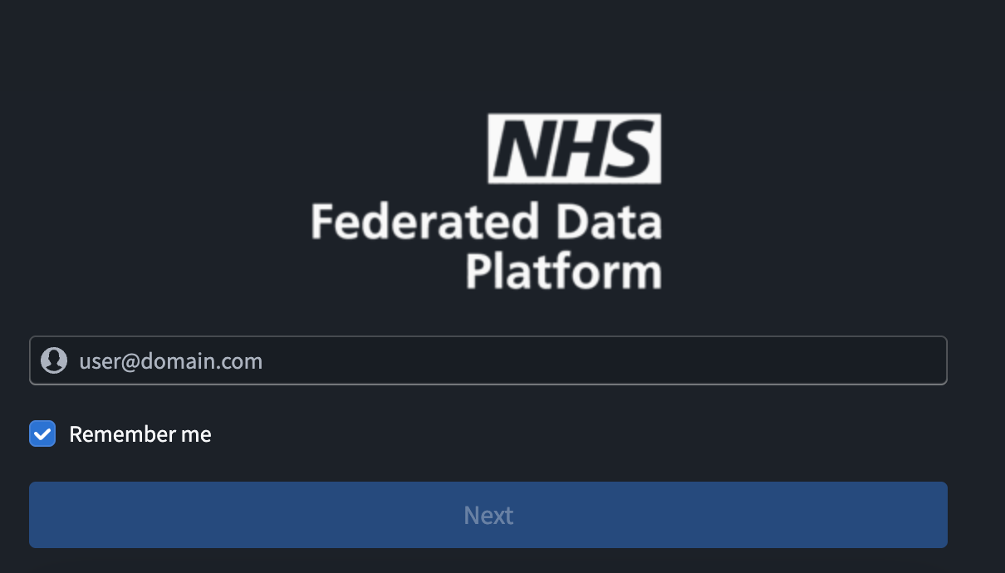

Enter your NHS email and click Next.

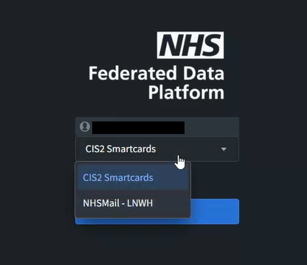

Select NHSMail – LNWH on the dropdown menu.

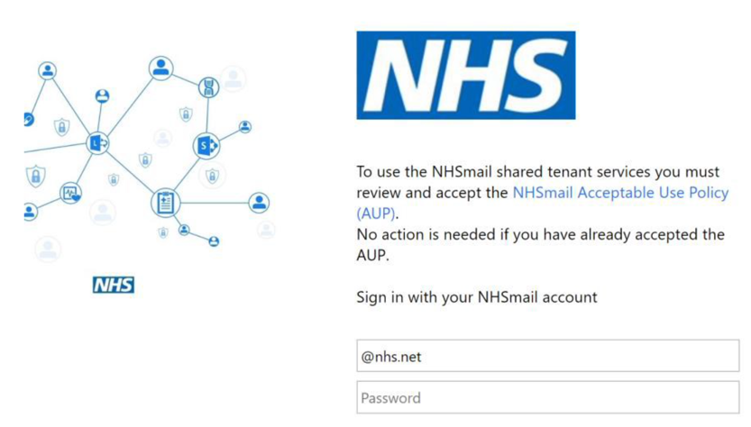
Enter your NHS email address and password.

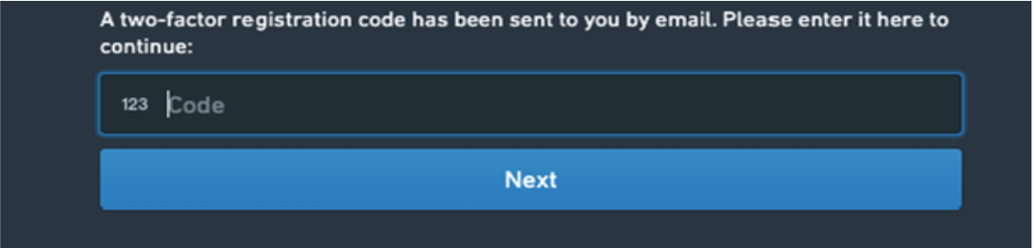

Check your email inbox/junk folder for the code. It may take a few minutes to receive the code. You will only need to do this on first login.

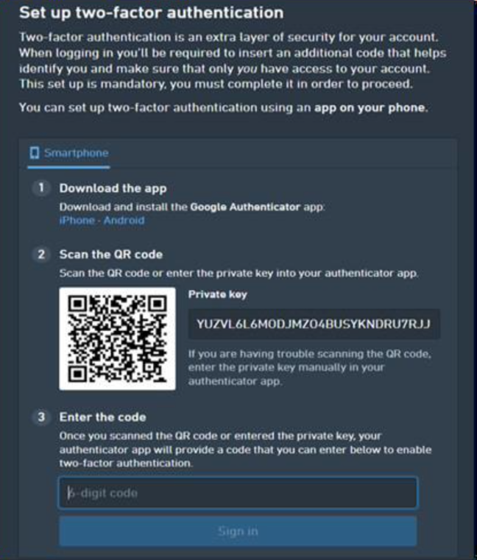

Click Sign in.

This step is only required on first login. Set up two factor authentication by downloading on your device the Microsoft Authenticator or Google Authenticator.

Then, using the app click ‘’Add a new account using the ‘’+’’ sign and scan the QR code, then enter the 6-digit code shown on your screen.

Note the 6-digit code updates every 30 seconds

If you are using a work phone, there should already be a pre-installed Microsoft Authenticator application. Then follow the same process as above.

For any subsequent logins you will only be asked to enter the 6-digit code generated by your authenticator app as part of the 2-factor authentication.

Submitting a referral

Dentists can access the Referral portal via the following the link, once they have been registered by LNWH and logged in for the first time:

https://lnwh.federateddataplatform.nhs.uk/workspace/module/view/latest/ri.workshop.main.module.6b867840-cebf-4cb5-9f7b-024db30d6694

- Access the Dentistry Referral Submission Form by navigating within the portal to Submit Dentistry Referral
- Ensure that ‘Submit Dentistry Referral’ is selected in the top right-hand corner.
- Fill in the form, ensuring that all the required fields (indicated by a red star) are completed as a minimum.
- Submit the completed form at the bottom of the page.

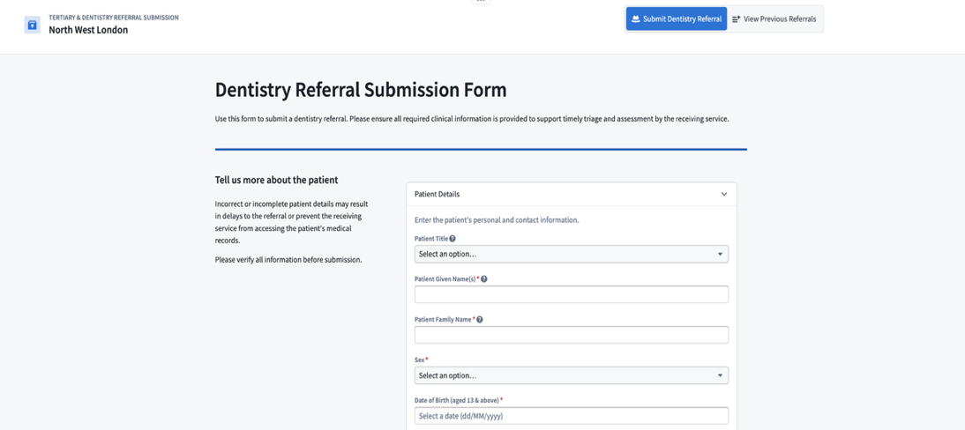

5. View previous referrals

- Access the Dentistry Referral Submission Form
- Ensure that ‘View Previous Referral’ is selected in the top right-hand corner.
- Select ‘Submitted Referrals’, ‘Accepted Referrals’ or ‘Rejected Referrals’ in the top left-hand corner. There are additional filters down the left-hand side of the page.
- Select an individual patient to view their details, referral, and attached documents

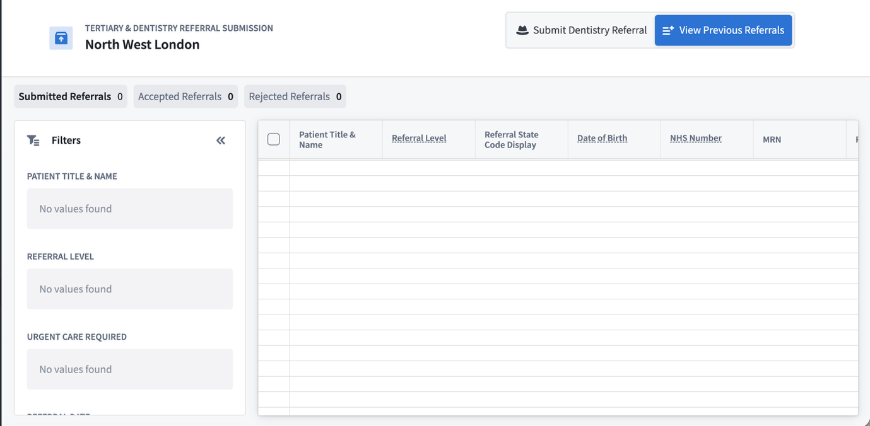

Users registered to the same practice will be able to view all referrals submitted by the practice users. This will ensure resilience and a systems approach.

6.Contacts

For technical support (access to the tool and workflow related issues) during the transition to the new portal, please use this email lnwh-tr.fdpexternalsupport@nhs.net

For escalations, please contact us via email:
- NPH - lnwh-tr.imos.bh@nhs.net
- Ealing- lnwh-tr.imos.eh@nhs.net
- Hillingdon- lnwh-tr.imos.hdon@nhs.net

Please note email inboxes are managed during working hours only and response times will vary depending on staff duties.

-END-

